DATA STRUCTURES AND ALGORITHM
23CSE203
LAB MANUAL

SUBMITTED BY:
NAME | S.Mohitha
ROLL NO | AV.SC.U4CSE25039
YEAR/SEM/SECTION | 2nd/3rd/CSE A
CREDITS | 05

SUBMITTED TO:
NAME | DR. RAJ KUMAR BATCHU
DESIGNATION | ASST.PROFESSOR (SI.Grade)
DEPARTMENT | SCHOOL OF COMPUTING

INDEX
S.NO | PROGRAM | PAGE NO
1 | WEEK1:  1(A). A rocket launch displays a countdown before launch. Instead of  using a loop, implement the countdown using recursion. Write a  recursive Python program to display a countdown from n to 1, followed  by “Launch!”.  1(B). Banks calculate the growth of an investment using compound  interest. The formula requires calculating powers, which can be  implemented recursively. Write a recursive program to calculate pⁿ  (power) where:  • p = principal growth factor  • n = number of years  1(C). An HR department stores employee IDs in a list. Develop a  recursive program to search for a given employee ID. Write a  recursive function to search for an employee ID in a list.  1(D). In a logistics company, the number of possible ways to arrange n  different parcels are calculated using the factorial formula (n!). Develop  a recursive program to calculate the factorial of a given number.  1(E). Write a recursive Python program to print the first n terms of  Fibonacci series
2 | WEEK2:  2(A). Write a Python program to implement linear search.  2(B) i. Write a Python program to implement binary search with sorted  array as an input.  2(B) ii. Write a Python program to implement binary search without  sorted array as an input
3 | WEEK 3:  3(A).Write a python program to implement bubble sort where the input  elements are taken from the user  3(B). Write a python program to implement insertion sort where the  input elements are taken from the user  3(C). Write a python program to implement selection sort where the  input elements are taken from the user

WEEK – 1
1)AIM: A rocket launch system displays a countdown before launch. Instead of using a loop implement the countdown using recursion .write a recursion python program to display a countdown from n to 1 followed by “launch”.
PROGRAM:
def launch(n):
for i in range(n,-1,-1):
if i==0:
print("launch")
else:
print(i)
n=int(input("enter no. of seconds to launch:"))
launch(n)
OUTPUT:
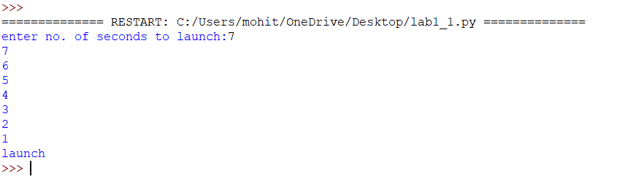
EXPLANATION:
This program displays a countdown from n to 1 and finally prints 'launch'. Although the aim mentions recursion, the given code uses a loop.
ERROR TABLE:
Error | Cause | Solution
Indentation Error | Incorrect indentation | Align blocks properly
Name Error | Variable not defined | Define before use
Value Error | Non-integer input | Enter valid integer

2)AIM: banks calculate the growth of an investment using compoundinterest the formula requires calculating powers. Which can be implemented recursively. Write a recursive program to calculate p^n(power),where p=principal growth factor, n= number of years.
PROGRAM:
def intrest(p,n):
if n==0:
return 1
else:
return p*intrest(p,n-1)
n=int(input("enter no.of years:"))
p=int(input("enter a number:"))
res=intrest(p,n)
print(res)
OUTPUT:
EXPLANATION:
This program recursively calculates p^n by multiplying p until n becomes 0.
ERROR TABLE:
Error | Cause | Solution
Recursion error | Very large value of n | Reduce input
Value Error | Non-integer input | Enter valid integer

3)AIM: An HR department stores employee ID’s in a list. Develop a recursive program to search for a given employee ID .write a recursive function to search for an employee ID in a list.
PROGRAM:
def search(m):
key=m
for i in range(n-1):
if arr[i]==key:
return i
n=int(input("enter no.of employees to add:"))
arr=[]
for i in range(n):
a=int(input("enter a value:"))
arr.append(a)
print(arr)
m=int(input("enter a element to search:"))
result=search(m)
if result==-1:
print(“element is not found”)
else:
print("employee id is stored at the index:",result)
OUTPUT:
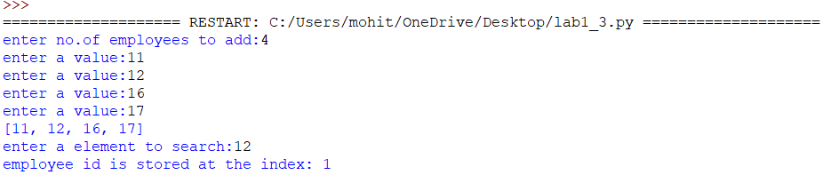
EXPLANATION:
This program searches for an employee ID in a list and returns its index if found.
ERROR TABLE:
Error | Cause | Solution
Syntax error | Wrong quotes/brackets | Correct syntax
Logic error | Returns None instead of -1 | Return -1 when not found

4)AIM: In a logistics company the number of possible ways to arrange n different parcels is calculated using the factorial formula(n!). develop a recursive program to calculate the factorial of a given number.
PROGRAM:
def fact(n):
fact=1
for i in range(1,n+1):
fact=fact*i
return fact
n=int(input("enter a number to find its factorial:"))
result=fact(n)
print(result)
OUTPUT:
EXPLANATION:
This program calculates the factorial of a number using iteration (not recursion).
ERROR TABLE:
Error | Cause | Solution
Overflow/large input | Large input value | Give smaller input
Value error | Invalid input | Even integer

5)AIM: write a recursive python program to print the first n terms of the Fibonacci series.
PROGRAM:
def fib(n):
if n==0:
return 0
elif n==1:
return 1
else:
return fib(n-1)+fib(n-2)
n=int(input("enter no of terms:"))
if n<=-1:
print("invalid input")
else:
for i in range(n):
print(fib(i),end=" ")
OUTPUT:
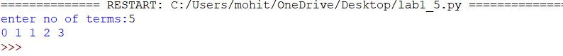
EXPLANATION:
The program uses recursion to generate Fibonacci numbers. fib (0)=0 and fib (1) =1 are the base cases. For every other term, fib(n)=fib(n-1) + fib(n-2). The loop prints the first n terms.
ERROR TABLE:
Error | Cause | Solution
Recursion error | Large value of n | Use iteration
Invalid input | Negative value of n | Validate input
Slow execution | Repeated recursive calls | Use dynamic programming

WEEK – 2
2(A). AIM:Write a Python program to implement linear search.
PROGRAM:
def linear_search(arr,key):
for i in range(len(arr)):
if arr[i] == key:
return i
return -1
n = int(input("Enter the number of elements:"))
arr = []
print("Enter the elements:")
for i in range(n):
arr.append(int(input()))
key = int(input("Enter the element to search:"))
result = linear_search(arr,key)
if result!=1:
print("Element found at index",result)
else:
print("Element not found")
OUTPUT:
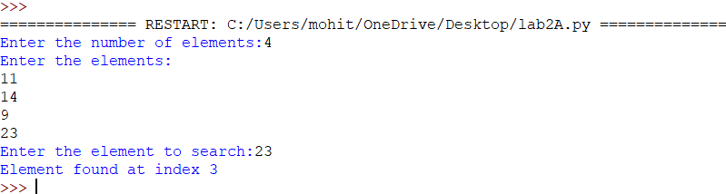
EXPLANATION:
The linear_search() function checks each element of the list one by one and compares
it with the given key.
If the key is found, its index is returned; otherwise, the function returns -1.
The program takes the array and search element as input and displays whether the
element is found.
ERROR TABLE:
S NO | ERRORS | RECTIFICATION
 | ValueError occurs if a non-integer value is  entered when int(input()) is used. | Enter only integer values for the  number of elements and array  elements.
 | TypeError may occur if len(arr) is used on  a variable that is not a list. | Make sure arr is initialized as a list  using arr = [] and elements are  appended to it.

2(B) i.AIM: Write a Python program to implement binary search with sorted array as an
input.
PROGRAM:
def linear_search(arr, key):
for i in range(len(arr)):
if arr[i] == key:
return i
return -1

n = int(input("Enter the number of elements:"))
arr = []

print("Enter the elements:")
for i in range(n):
arr.append(int(input()))

key = int(input("Enter the element to search:"))
result = linear_search(arr, key)

if result != -1:
print("Element found at index", result)
else:
print("Element not found")
OUTPUT:
POSITIVE OUTPUT:
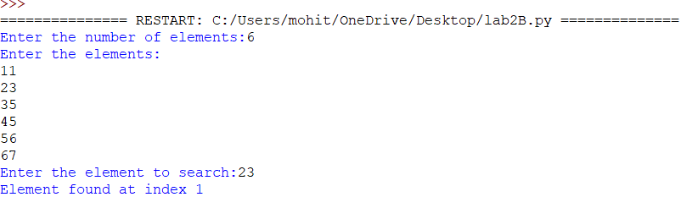
NEGATIVE OUTPUT:
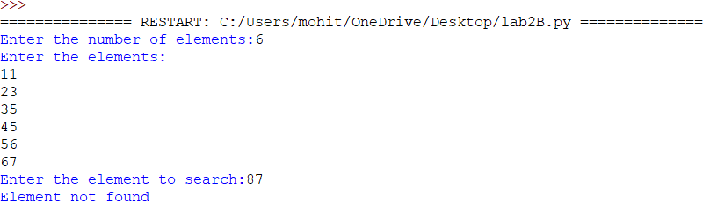
EXPLANATION:
1. The program takes a sorted array as input and searches for the required element using
binary search.
13
2. It checks the middle element and eliminates either the left or right half based on the
comparison.
3. If the element is found, its position is displayed; otherwise, it prints “Element not
found.”
S.NO | ERRORS | Rectification
1. | Binary search may give an incorrect result  if the input array is unsorted. | Check whether the array is sorted and  use arr.sort() before  calling binary_search().
2. | IndexError can occur if mid is calculated  or the low/high boundaries are modified  incorrectly | Initialize low = 0, high = len(arr) - 1 and  update them as low = mid + 1 or high =  mid - 1.

2(B) ii.AIM: Write a Python program to implement binary search without sorted array as an input
PROGRAM:
def binary_search(arr,target):
arr.sort()
left = 0
right = len(arr) - 1
while left <= right:
mid = (left + right) // 2
if arr[mid] == target:
return mid
elif arr[mid] < target:
left = mid + 1
else:
right = mid - 1
return -1
n = int(input("Enter the number of elements:"))
arr = []
print("Enter the elements:")
for i in range(n):
arr.append(int(input()))
target = int(input("Enter the element to search:"))
index = binary_search(arr,target)
print("Sorted array:",arr)
if index != -1:
print(f"Element found at index {index} in the sorted array.")
else:
print("Element not found.")
OUTPUT:
POSITIVE OUTPUT:
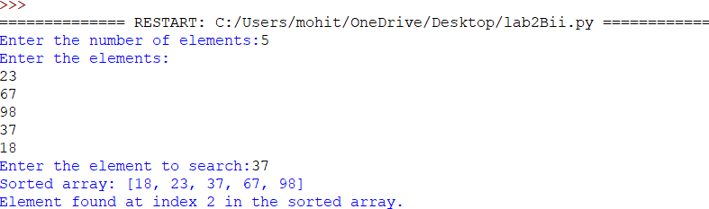
NEGATIVE OUTPUT:
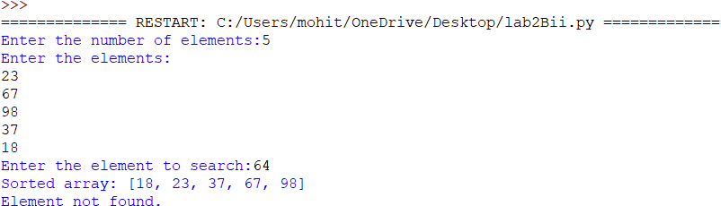
EXPLANATION:
1. The program takes an unsorted array as input and first sorts it using arr.sort().
2. It then uses binary search by checking the middle element and reducing the search
range.
3. If the element is found, its position is displayed; otherwise, it prints “Element not
found.”
ERROR TABLE:
S.NO. | ERRORS | RECTIFICATION
1. | Logical Error | Use a found variable and print “Element  not found” if it remains False.
2. | Logical Error | Use mid = (low + high) // 2 to calculate  the middle index.

WEEK-3
3A.
AIM:Write a python program to implement bubble sort where the input elements are
taken from the user
PROGRAM:
n = int(input("Enter the number of elements: "))

arr = []

for i in range(n):
element = int(input(f"Enter element {i + 1}: "))
arr.append(element)

for i in range(n - 1):
for j in range(n - 1 - i):
if arr[j] > arr[j + 1]:
arr[j], arr[j + 1] = arr[j + 1], arr[j]

print("Sorted elements:", arr)
OUTPUT:
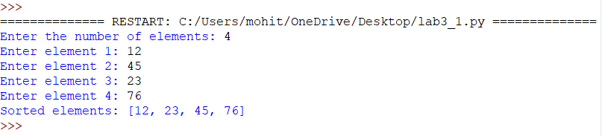
EXPLANATION:
1. The program takes the number of elements and their values from the user and stores
them in an array.
2. Bubble Sort compares adjacent elements and swaps them if they are in the wrong
order.
3. After all passes, the array is sorted in ascending order and displayed.
ERROR TABLE:
S.NO | ERRORS | RECTIFICATION
1 | Name Error | Initialize arr = [] before taking input
2 | Value Error | Enter only integer values

3(B).AIM:Write a python program to implement insertion sort where the input elements are
taken from the user
PROGRAM:
n = int(input("Enter the number of elements: "))

arr = []

for i in range(n):
element = int(input(f"Enter element {i + 1}: "))
arr.append(element)

for i in range(1, n):
key = arr[i]
j = i - 1

while j >= 0 and arr[j] > key:
arr[j + 1] = arr[j]
j -= 1

arr[j + 1] = key

print("Sorted elements:", arr)
OUTPUT:
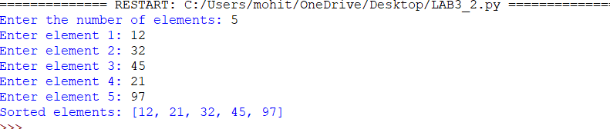
EXPLANATION:
1.The program takes the number of elements and their values from the user and stores them
in an array.
2.Insertion Sort selects each element and inserts it into its correct position among the
previously sorted elements.
3. Finally, the sorted array is displayed in ascending order.
ERROR TABLE:
S.NO. | ERRORS | RECTIFICATION
1 | SyntaxError | Use insertion_sort with an underscore.
2 | Name Error | Call insertion_sort(arr) correctly.

3(C).AIM:Write a python program to implement selection sort where the input elements are
taken from the user
PROGRAM:
def merge_sort(arr):
if len(arr) > 1:
mid = len(arr) // 2

left = arr[:mid]
right = arr[mid:]

merge_sort(left)
merge_sort(right)

i = 0
j = 0
k = 0

while i < len(left) and j < len(right):
if left[i] < right[j]:
arr[k] = left[i]
i += 1
else:
arr[k] = right[j]
j += 1
k += 1

while i < len(left):
arr[k] = left[i]
i += 1
k += 1

while j < len(right):
arr[k] = right[j]
j += 1
k += 1

n = int(input("Enter the number of elements: "))

arr = []

for i in range(n):
element = int(input(f"Enter element {i + 1}: "))
arr.append(element)

merge_sort(arr)

print("Sorted elements:", arr)
OUTPUT:
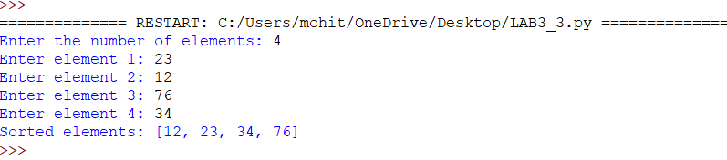
EXPLANATION:
1. The program takes the number of elements and their values from the user and stores
them in an array.
2. Selection Sort finds the smallest element and swaps it with the first unsorted element.
3. This process continues until the array is completely sorted in ascending order.
ERROR TABLE:
S.NO. | ERRORS | RECTIFICATION
1 | NameError | Initialize arr = [] before taking input.
2 | Value Error | Enter only integer values

3(d).AIM:Write a python program to implement quick sort where the input elements are
taken from the user
PROGRAM:
def quick_sort(arr):

if len(arr) <= 1:
return arr

pivot = arr[-1]

left = []
right = []

for i in arr[:-1]:
if i < pivot:
left.append(i)
else:
right.append(i)

return quick_sort(left) + [pivot] + quick_sort(right)

n = int(input("Enter the number of elements:"))

arr = []

for i in range(n):
element = int(input(f"Enter element{i + 1}:"))
arr.append(element)

arr = quick_sort(arr)

print("Sorted elements:", arr)
OUTPUT:
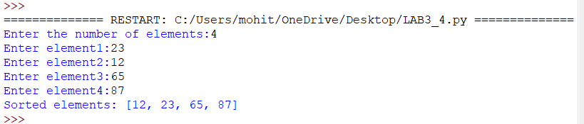

3E.AIM:Write a python program to implement selection sort where the input elements are taken from the user
PROGRAM:
n = int(input("Enter the number of elements: "))

arr = []

for i in range(n):
element = int(input(f"Enter element {i + 1}: "))
arr.append(element)

for i in range(n - 1):
min_index = i

for j in range(i + 1, n):
if arr[j] < arr[min_index]:
min_index = j

arr[i], arr[min_index] = arr[min_index], arr[i]

print("Sorted elements:", arr)
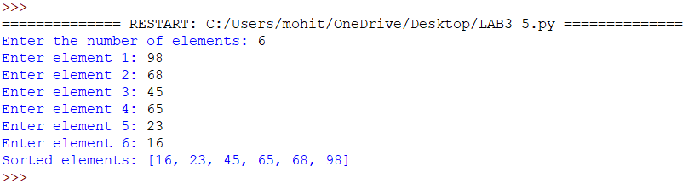
EXPLANATION:
1. The program takes the number of elements and their values from the user and stores
them in an array.
2. Selection Sort finds the smallest element and swaps it with the first unsorted element.
3. This process continues until the array is completely sorted in ascending order.
ERROR TABLE:
S.NO. | ERRORS | RECTIFICATION
1. | TypeError | Convert input values using int(input())..
2. | Logic Error | Update min_index correctly and swap arr[i] with arr[min_index].

